 | 12.1.73 Editors - Geometry Nodes Editor - Header - Add Menu - Geometry Nodegroups - Utilities - Vector
Table of content
Detailed table of content 1
Add menu - Geometry nodegroups - Utilities - Vector 1
Combined Cylindrical 2
Combined Spherical 2
Separate Cylindrical 2
Separate Spherical 2

Detailed table of content
Detailed table of content
Detailed table of content 1
Add menu - Geometry nodegroups - Utilities - Vector 1
Combined Cylindrical 2
Combined Spherical 2
Separate Cylindrical 2
Separate Spherical 3

Add menu - Geometry nodegroups - Utilities - Vector

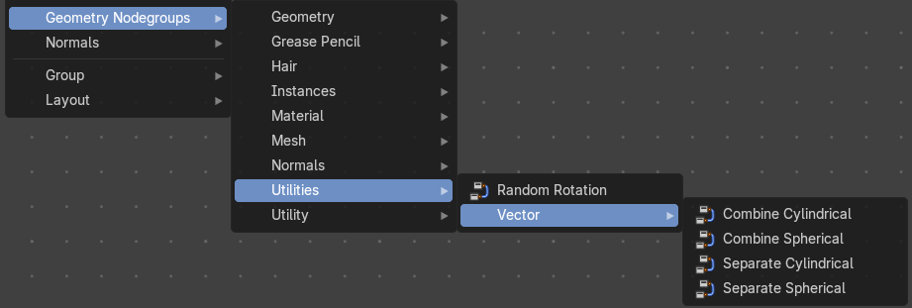
The nodes in this submenu are node groups. They use the regular single nodes under the hood.
It is virtually impossible to document these nodes in detail. So we will just list them.
When you double click the header, then you will enter the first level of the group. When you then press tab, or click again at the header, then you will reach the single nodes.




To leave the group you can use the breadcrumb up left in the header. These breadcrumbs are clickable. Or the Parent Node Tree button up right in the header.

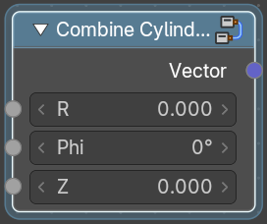
Combined Cylindrical
Create a vector from its cylindrical components.

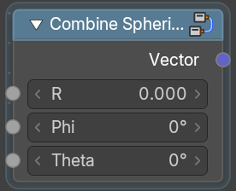
Combined Spherical
Create a vector from its spherical components.

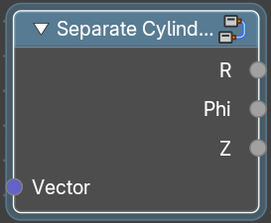
Separate Cylindrical
Decompose into its cylindrical components.

Separate Spherical
Decompose into its spherical components.

